BL7U
beamline（11pt）
Title of the Presentation (gothic, 18pt）

Shin-ichiro Ideta^{1,2} Masahiro Sakai¹, and Kiyohisa Tanaka^{1,2}
¹UVSOR Facility, Institute for Molecular Science,
²The Graduate University for Advanced Studies

This is the instruction for preparation of abstract and is itself an example of page layout. Abstract should be written in Japanese (in that case, please see the template in Japanese) or English and submitted in a one-page PDF format. Title of the abstract should be centered and typed in gothic, bold 18-point font. Capitalize the first letter of each word of the title other than prepositions, conjunctions, and articles. All authors should be listed followed by their affiliation(s) (gothic, 14 point). Use numbers to include the different affiliations of the authours. Underline the name of the presenting authors. The author list and author-affiliation list should be centered. Insert another blank line between the authors and the body of the abstract. Please write in the beamline on the upper left.
When figures are included, be sure that they are neatly prepared and fit within one page. Each figure should have a brief caption in gothic, 11-point font below the figure.
Call out references in the text within a numeral in brackets (e.g. [1]). Number all references sequentially as they appear in the text, starting with [1]. Make all references complete bibliographic citations, including author, place of publication, volume, year, and the first page of the referred part. Reference should be placed at the very end as this template.
All abstracts should be submitted electronically (PDF format) by September 30 (Fri), 2016 though the symposium website at http://registration.ims.ac.jp/UVSORSympo2016/presentation after the registration at http://registration.ims.ac.jp/UVSORSympo2016/registration. You can upload up to three abstracts. You can change the format somewhat; however, please do not modify the font, its size, and the location in this abstract.
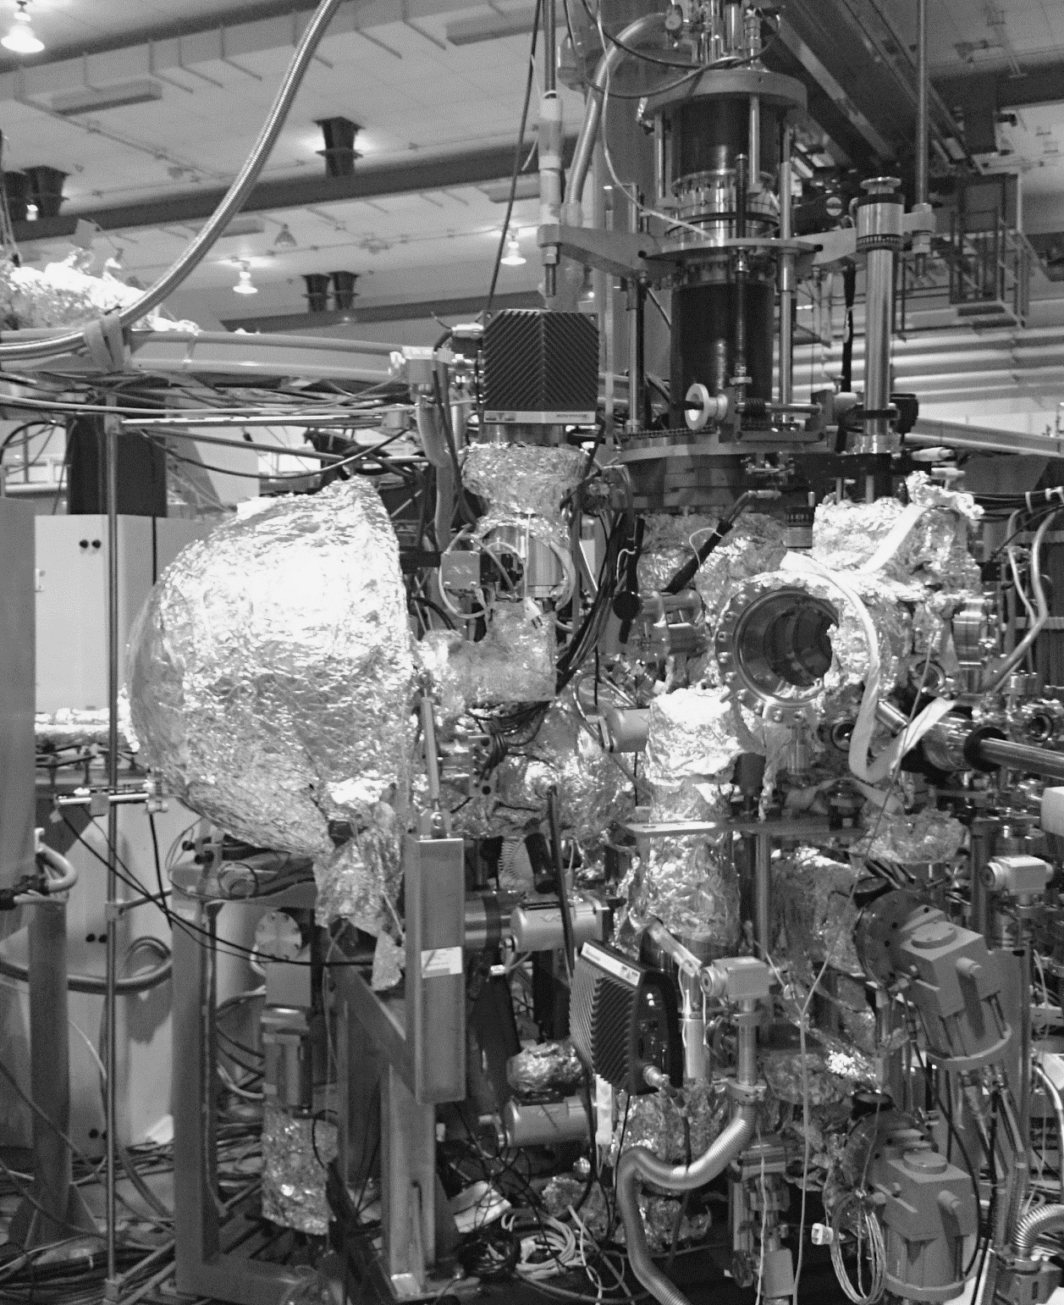
Color figure is allowed
main text (11pt)
Fig. 1: Figure caption (gothic, 11pt)

[1] S. Ideta et al., journal, volume pages (year). （gothic, 10pt）

