BL##
Template File for UVSOR Activity Report 2023: You Can Write Your Manuscript Directly on This File
A. Author^{1,2}, B.C. Author³ and D. Author³
¹Editorial Board, UVSOR Synchrotron Facility, Institute for Molecular Science, Okazaki 444-8585, Japan
²School of Physical Sciences, The Graduate University for Advanced Studies (SOKENDAI), Okazaki 444-8585, Japan
³Affiliation, Address ###-####, Country

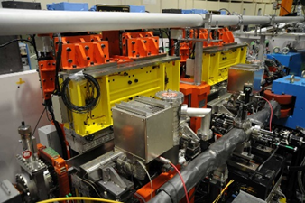
This is the style file for the format of Users’ Reports [1]. Fonts of Times, Times New Roman and Symbol are applicable to your reports, including figure legends and blank spaces. The font sizes and styles for your reports are listed in Table 1 [1, 2]. In addition, the examples for references are shown in the end of this draft [1-3].
At the beginning of each paragraph, two space characters should be inserted as an indent.
Regarding the beamline name of UVSOR, no hyphen between BL and its number is needed.
Regarding the Figure, "Figure #" and "Fig. #" should be used at the beginning of sentence and in the sentence, respectively.

Fig. 1. Photo of the variably polarized U1 undulators in tandem.

Table 1. Font size and style.
 | Font Size | Style
Beamline | 10 pt | Normal
Title | 14 pt | Bold
Author Name | 12 pt | Normal
Affiliation | 10 pt | Italic
Text | 10 pt | Normal
Ref: Text | 10 pt | Normal
Ref: et al | 10 pt | Italic
Ref: Volume | 10 pt | Bold
Caption | 10 pt | Normal

[1] M. Sakai, H. Hagiwara and K. Tanaka, UVSOR Activity Report 33 (2006) 1.
[2] T. Ohigashi et al., Phys. Rev. Lett. vol (year) page.
[3] M. Matsunami, Textbook (MM Press, Okazaki, 2012).

