Institute for Molecular Science

Radiation Worker Application Form (For External User)
Submission Date: | 20 / /
 | (Year) (Month) (Day)

To: Director General of Institute for Molecular Science (IMS)

I hereby apply to be registered as a radiation worker.
Full Name | Last name, First name, (middle initial) |  | Sex |  | □Male □Female
Date of Birth | Year Month Day |  | E-mail
Date of Birth | Y /M /D
Affiliation | Name of Organization |  |  | Contracted Name (Up to 6 char.)
Affiliation | Division/Section |  |  | Title or Current year PhD/MS/BS
Work Place | Synchrotron radiation, Accelerator  □UVSOR facility  (Include the use of STXM, XMCD) | X-ray generator  □Instrument Center  □Equipment Development Center  □Other ( Lab.)
Name of collaborative researcher | Please fill in IMS researcher name collaborating.
Work Period | The work (scheduled) starting date | Do not exceed the next fiscal year*
Work Period | From Y20 /M /D | To Y20 /M /D
Health Check | □Normal  □Not Normal (Attach the copy of health check results)  The person using only X-ray generators is possible in the blank.
Dose amount of radiation exposure | The result of the last fiscal year.
Dose amount of radiation exposure | □Less than 1mSv  □More than or equal 1mSv [ mSv] (Attach the copy of health check results)
* Japan's fiscal year runs from April 1 till March 31 in the following year.

Certificate of authorization by affiliated organization
I hereby certify that the above-named person is subject to radiation safety and control and is authorized to work in radiation-controlled areas at IMS.

Name of Organization/Company:
Title of the representative for the organization above:
Name of the representative for the organization above:
Signature

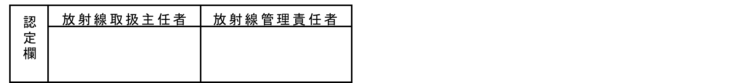
(Fill in the following IMS.)

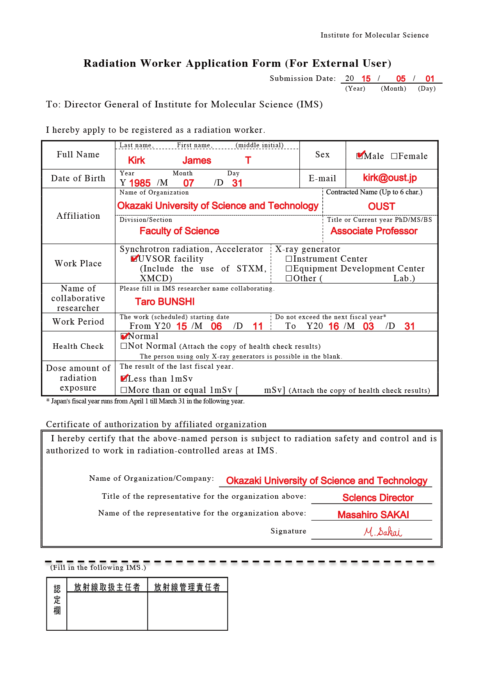
Please fill in expriment starting date.
Please fill in contracted name of youre organization. ( maximum of 6 alphanumeric characters)

Example
Please fill in most recent March 31.

